MODUL 3. GERBANG LOGIKA

NIM : L200180017

Nama : Virliana AR

Nama Assisten : Riza

Tanggal Praktikum : 13 Maret 2019

**Percobaan 1. Gerbang AND**

1. **Buat rangkaian**

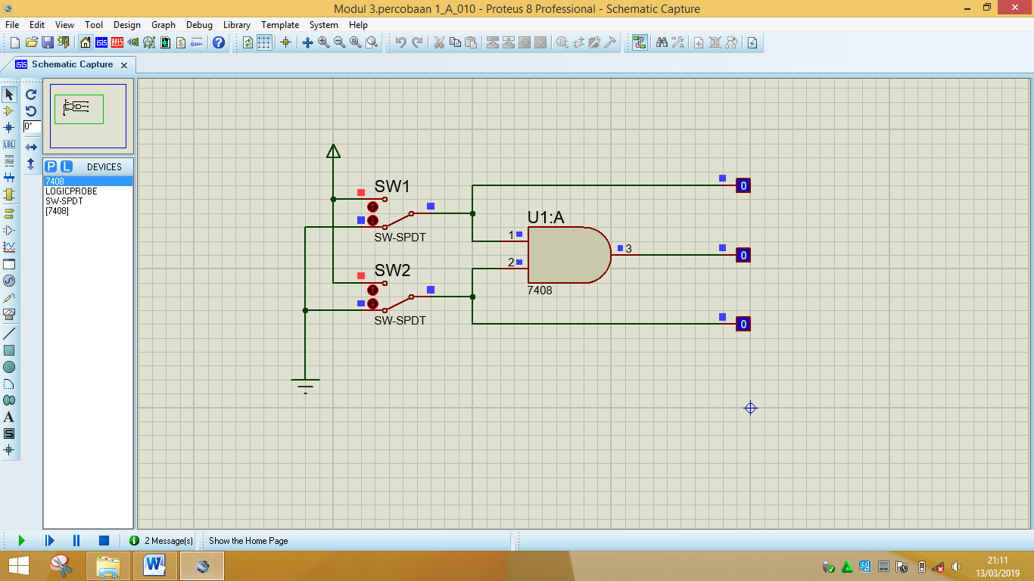

**2. Fungsi boolean : L3 = L1 L2** atau **L3 =L1.L2**

**3. Tabel kebenaran**

|  |  |  |  |  |
| --- | --- | --- | --- | --- |
| SW 1 | SW 2 | L1 | L2 | L3 |
| 0 | 0 | 0 | 0 | 0 |
| 1 | 0 | 1 | 0 | 0 |
| 0 | 1 | 0 | 1 | 0 |
| 1 | 1 | 1 | 1 | 1 |

**4. Diagram waktu**

|  |  |  |  |
| --- | --- | --- | --- |
|  |  |  |  |
|  |  |  |  |
|  |  |  |  |
|  |  |  |  |
|  |  |  |  |
|  |  |  |  |

|  |
| --- |
| L1 |
| L2 |
| L3 |

**Percobaan 2. Gerbang OR**

1. **Buat rangkaian**

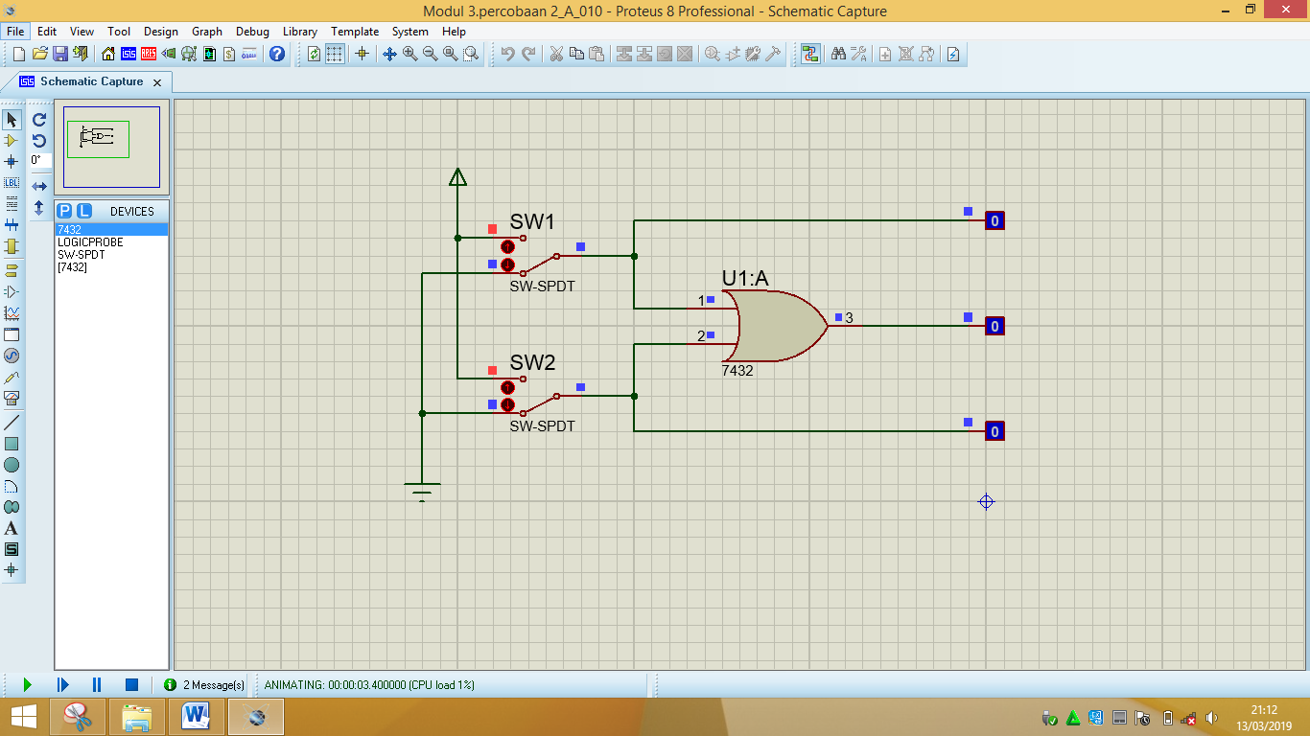

**2. Fungsi boolean : L3 = L1 + L2**

**3. Tabel kebenaran**

|  |  |  |  |  |
| --- | --- | --- | --- | --- |
| SW 1 | SW 2 | L1 | L2 | L3 |
| 0 | 0 | 0 | 0 | 0 |
| 1 | 0 | 1 | 0 | 1 |
| 0 | 1 | 0 | 1 | 1 |
| 1 | 1 | 1 | 1 | 1 |

**4. Diagram waktu**

|  |  |  |  |
| --- | --- | --- | --- |
|  |  |  |  |
|  |  |  |  |
|  |  |  |  |
|  |  |  |  |
|  |  |  |  |
|  |  |  |  |

|  |
| --- |
| L1 |
| L2 |
| L3 |

**Percobaan 3. Gerbang NOT**

1. **Buat rangkaian**

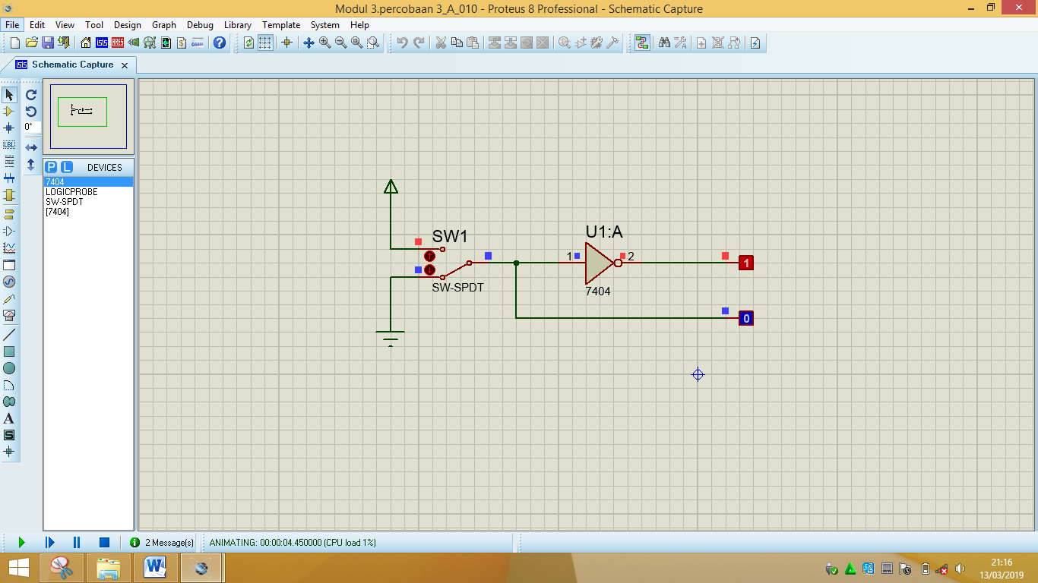

**2. Fungsi boolean : L1 = ~L2** atau  **L1 = L2**

**3. Tabel kebenaran**

|  |  |  |
| --- | --- | --- |
| SW 1 | L1 | L2 |
| 0 | 1 | 0 |
| 1 | 0 | 1 |

**4. Diagram waktu**

|  |  |
| --- | --- |
|  |  |
|  |  |
|  |  |
|  |  |

|  |
| --- |
| L1 |
| L2 |

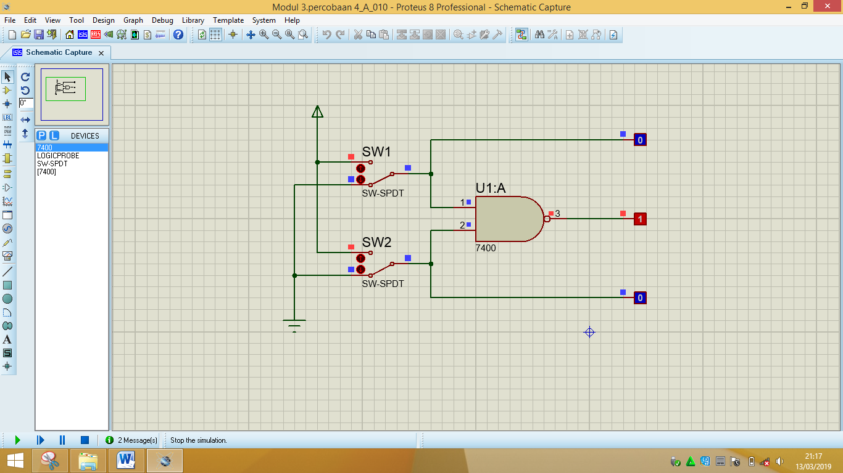**Percobaan 4. Gerbang NAND**

1. **Buat rangkaian**

**2. Fungsi boolean : L3 = L1 L2** atau **L3 = L1.L2**

**3. Tabel kebenaran**

|  |  |  |  |  |
| --- | --- | --- | --- | --- |
| SW 1 | SW 2 | L1 | L2 | L3 |
| 0 | 0 | 0 | 0 | 1 |
| 1 | 0 | 1 | 0 | 1 |
| 0 | 1 | 0 | 1 | 1 |
| 1 | 1 | 1 | 1 | 0 |

**4. Diagram waktu**

|  |  |  |  |
| --- | --- | --- | --- |
|  |  |  |  |
|  |  |  |  |
|  |  |  |  |
|  |  |  |  |
|  |  |  |  |
|  |  |  |  |

|  |
| --- |
| L1 |
| L2 |
| L3 |

**Percobaan 5. Gerbang NOR**

1. **Buat rangkaian**

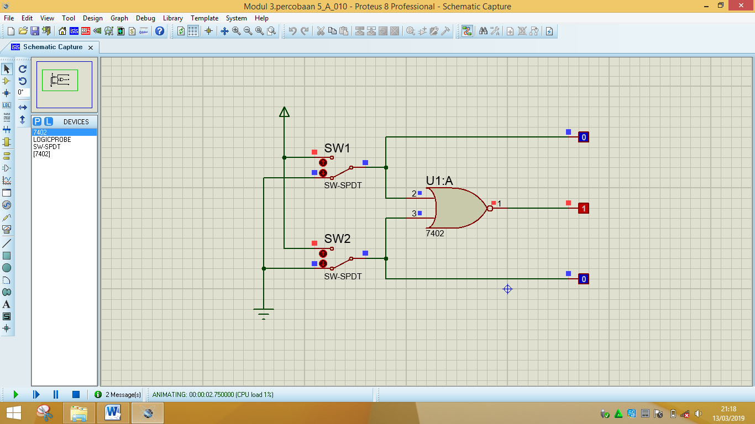

**2. Fungsi boolean : L3 = L1 + L2**

**3. Tabel kebenaran**

|  |  |  |  |  |
| --- | --- | --- | --- | --- |
| SW 1 | SW 2 | L1 | L2 | L3 |
| 0 | 0 | 0 | 0 | 1 |
| 1 | 0 | 1 | 0 | 0 |
| 0 | 1 | 0 | 1 | 0 |
| 1 | 1 | 1 | 1 | 0 |

**4. Diagram waktu**

|  |
| --- |
| L1 |
| L2 |
| L3 |

|  |  |  |  |
| --- | --- | --- | --- |
|  |  |  |  |
|  |  |  |  |
|  |  |  |  |
|  |  |  |  |
|  |  |  |  |
|  |  |  |  |

**Percobaan 6. Gerbang XOR**

1. **Buat rangkaian**

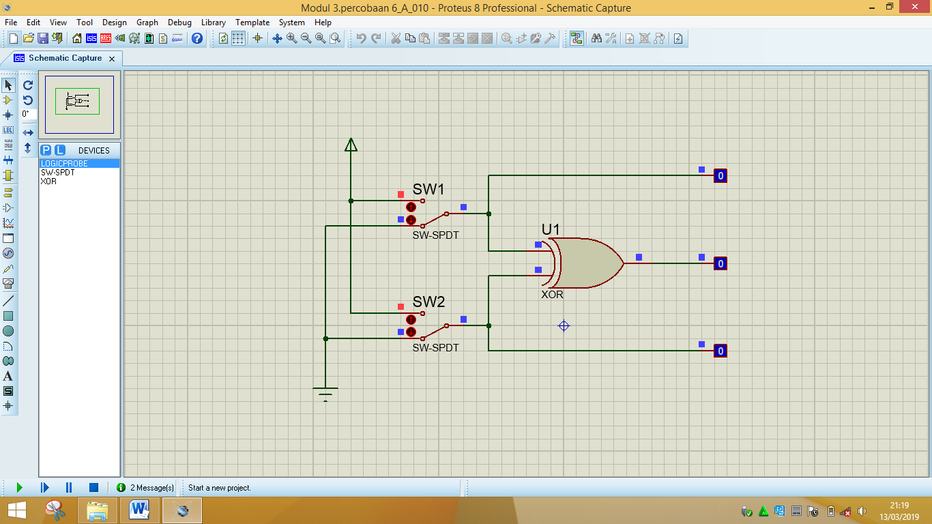

**2. Fungsi boolean : L3 = L1 L2**

**3. Tabel kebenaran**

|  |  |  |  |  |
| --- | --- | --- | --- | --- |
| SW 1 | SW 2 | L1 | L2 | L3 |
| 0 | 0 | 0 | 0 | 0 |
| 1 | 0 | 1 | 0 | 1 |
| 0 | 1 | 0 | 1 | 1 |
| 1 | 1 | 1 | 1 | 0 |

**4. Diagram waktu**

|  |  |  |  |
| --- | --- | --- | --- |
|  |  |  |  |
|  |  |  |  |
|  |  |  |  |
|  |  |  |  |
|  |  |  |  |
|  |  |  |  |

|  |
| --- |
| L1 |
| L2 |
| L3 |

**Percobaan 7. Gerbang XNOR**

1. **Buat rangkaian**

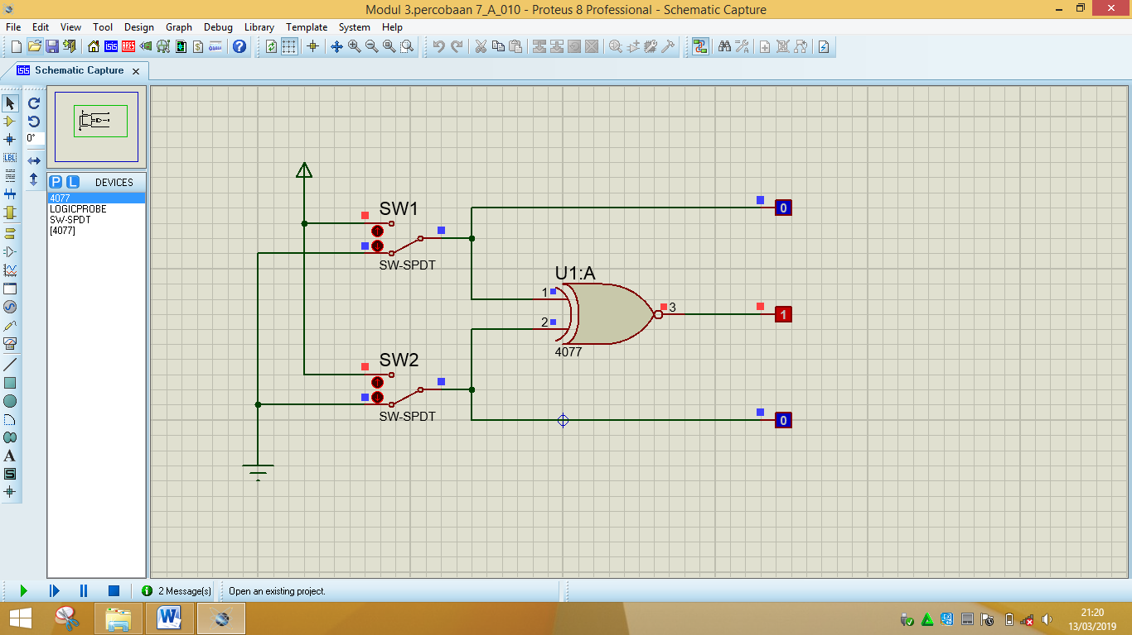

**2. Fungsi boolean : L3 = L1 L2**

**3. Tabel kebenaran**

|  |  |  |  |  |
| --- | --- | --- | --- | --- |
| SW 1 | SW 2 | L1 | L2 | L3 |
| 0 | 0 | 0 | 0 | 1 |
| 1 | 0 | 1 | 0 | 0 |
| 0 | 1 | 0 | 1 | 0 |
| 1 | 1 | 1 | 1 | 1 |

**4. Diagram waktu**

|  |  |  |  |
| --- | --- | --- | --- |
|  |  |  |  |
|  |  |  |  |
|  |  |  |  |
|  |  |  |  |
|  |  |  |  |
|  |  |  |  |

|  |
| --- |
| L1 |
| L2 |
| L3 |